16 Creating Enemies

The main subject for this tutorial is to create a few enemies for our hero to fight, But first I think I might want to spruce up the dungeon floor just a bit. I tried adding brick or stone floors, but the elements did not show up very well, so I decided I need a darker floor. Yes, black marble isn’t exactly what is on most dungeon floors, but it just looked so cool, I decided to keep it.

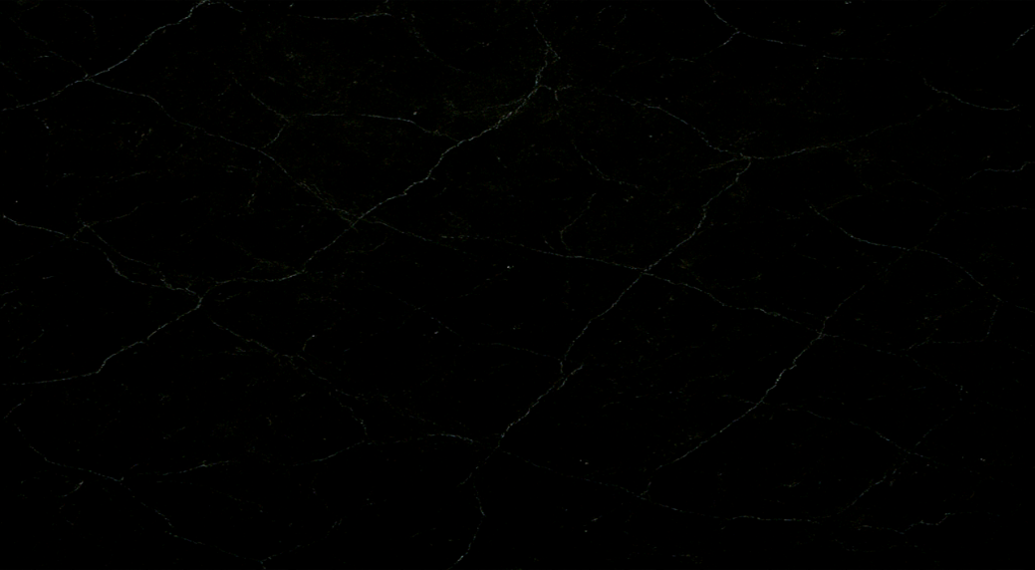

We need our floor to come in at a size of 1280 x 704. Create a sprite for it through the sprite panel and then just assign the sprite to the room’s background layer.

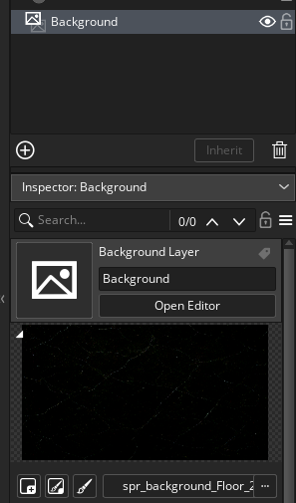

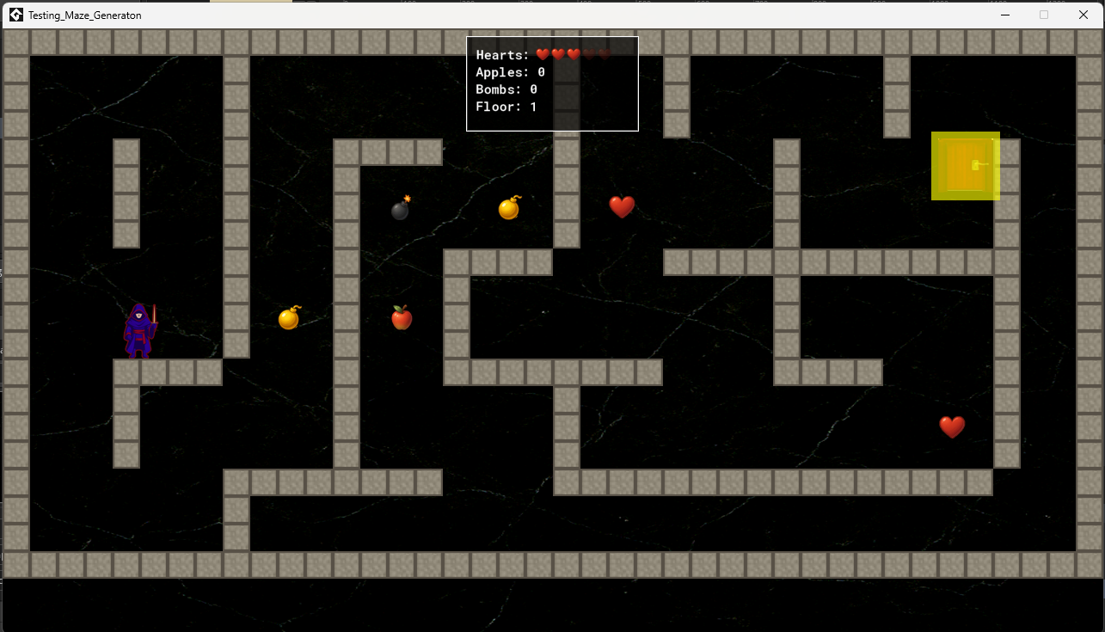

# Creating the Enemies

Folder Structure for the Sprites will be first. We have one main folder called Enemies, inside that folder, we have a folder for each type of enemy, then inside of each enemy folder, you need 4 folders each for each film strip.

We need a different film strip for each phase of monster behavior.

Idle

Attack

Hit

Death

